PRACTICAL TRAINING REPORT

NATIONAL SHRESTHA
041902900040

INFRASTRUCTURE UNIVERSITY KUALA LUMPUR

PRACTICAL TRAINING

CSC 3820

SEPTEMBER SEMESTER 2021

Sunway International Business School
Maitidevi, Kathmandu

NATIONAL SHRESTHA
041902900040

BACHELOR OF COMPUTER SCIENCE (HONS.)
FACULTY OF SCIENCE AND TECHNOLOGY
INFRASTRUCTURE UNIVERSITY KUALA LUMPUR

SHARAD CHANDRA PAUDEL
041902900074

INFRASTRUCTURE UNIVERSITY KUALA LUMPUR

DECLARATION

This report has been prepared as the partial requirement for CSC 3820 practical training.

ENDORSED BY


ACKNOWLEDGEMENT

Foremost, I would like to express my genuine gratitude towards Sunway International Business School & IUKL for allowing me to enroll myself in the course ‘Industrial Training’, which allowed me to gain some real-life work experience through internship program for the time period of 3 months.

I would then like to express my gratitude towards my field supervisor Mr. Rabin Shrestha & the entire team of full stack developer (Mind Riser's Consortium.) for allowing me to be a part of their team as an intern. And also, for allowing me to learn so many things during my time working as an intern.

Finally, I would also like to thank Dr. Rajeev Kumar Shah for his guidance throughout this course duration to help me understand the essence of this course and also for the opportunities he introduced to me.

Table of Contents
DECLARATION iii
ENDORSED BY iv
ACKNOWLEDGEMENT v
Table of Figures vii
Introduction 1
Introduction: 1
Organizational Background 2
2.1 Organizational Background: 2
SUMMARY OF THE JOB FUNCTIONS: 3
3.1 Tasks given by supervisor: 3
Problems encountered during the training 4
4.1 Problems & solution during the internship: 4
4.2 Personal Problems: 4
Summary of experience gained 5
5.1 Technical Skills: 5
5.2 Soft Skills: 5
Conclusion 6
Appendix 7

Table of Figures
Fig 1: Office Building of Mind Riser's Consortium. 7
Fig 2: Interior Workspace of Mind Riser's Consortium. 7

Introduction

Introduction:

Industrial training is a practical learning program/work experience for students enrolled in a college. Students will gain work experience in a real workplace context. They will comprehend the workflow and the purpose of the work in a professional setting. It benefits students' professional development by providing experience and understanding about the interaction between study and employment.

As part of my Bachelor of Computer Science (Hons.) course, the internship program was designed as a part of Industrial Training course by the ‘Infrastructure University Kuala Lumpur’. This course has helped me to grasp the opportunity where my theoretical knowledge could be applied somehow in a practical context or to say to the real world.

The organization named Mind Riser's Consortium hired me as a "Frontend developer Intern" around 3 months back. Within the period, I have tried to compile the experiences that I had gained to apply it in the internship course.

I began my internship under the guidance of HR and senior developer Mr. Rabin Shrestha of Mind Riser's Consortium. I was first introduced to the different tasks that the company does, where I could understand the company’s motivation and field of work. Then I was introduced to the tasks that I had to do in coming days and as a part of my training. I was told to make UI for projects. Later I was also assigned to do some tasks like make form,
Do some code in react for the project.

I believe Mind Riser's Consortium has provided me with a subtle opportunity to share my expertise as a coder as well as UI designer. They use redux toolkit to manage state in react which was absolutely new to me. The team was extremely kind and helpful to me.

Organizational Background

2.1 Organizational Background:

MIND RISER'S CONSORTIUM IT Company is a dynamic and innovative organization that has been at the forefront of the IT industry for over a decade. With a strong commitment to delivering cutting-edge solutions and exceptional client service, MIND RISER'S CONSORTIUM IT Company has established itself as a trusted partner for businesses across various sectors.

MIND RISER'S CONSORTIUM IT Company was founded in 2010 by a team of experienced IT professionals with a shared vision of leveraging technology to drive business growth and transformation. Since its inception, the company has steadily grown its operations and client base, becoming a recognized player in the IT industry.

Mission:
Our mission is to empower businesses with transformative IT solutions that enhance efficiency, productivity, and profitability. We strive to deliver innovative technology solutions that align with our clients' unique needs and help them stay ahead in the digital age.

Vision:
Our vision is to be a leading provider of IT solutions globally, renowned for our expertise, customer-centric approach, and ability to drive tangible results for our clients. We aim to be the go-to partner for businesses seeking to leverage technology for competitive advantage.

Services:
MIND RISER'S CONSORTIUM IT Company offers a comprehensive range of IT services to meet the diverse needs of our clients. Our core services include: Custom Software Development, Web and Mobile App Development, IT Consulting, Cloud Solutions, IT Infrastructure Management.

SUMMARY OF THE JOB FUNCTIONS:

3.1 Tasks given by supervisor:

This section contains the details about the task that I had been assigned to do and the roles that I played during my internship period. As a role designated for me was a frontend developer intern, I was asked to do the following tasks:

- UI/UX implement in the code
- Write clean, efficient, and maintainable code to create interactive and dynamic web pages.
- Use popular framework like ReactJS.
- Make API requests, handle responses, and integrate the data seamlessly into the frontend application.
- Optimizing the performance of website
- Collaborating with the UI/UX and backend developer

Problems encountered during the training

4.1 Problems & solution during the internship:

Problem | Solution
I had very little idea about frontend development so some terminologies were new. | I took the help from YouTube to understand them.
Redux toolkit is very new to me | Took the help from senior developer and watching in YouTube to understand them
Lack of experience to understand the code of other developer. | Took help from the senior developer
Made a lot of mistakes while writing code | Used the ChatGPT to rectify those mistakes.

4.2 Personal Problems:
Most of my personal problem came when I was on home doing the tasks assigned to me. I was distracted frequently by the family members and also, I could not focus on the tasks. And having to repeat the same tasks, I for once lost the sense of learning something new and I almost quit the internship. However, I motivated myself and talked to my friends about it and later I continued my tasks.

Besides, being completely new to the frontend development, I was getting bored frequently and was also seeking for some other internship opportunities. Although I couldn’t find the other opportunities that would interest me, so I quit searching and focused on my current internship.

Having said that, I was also annoyed by my internet connection as it got extremely slow and it took a long period to reboot. I had to call my ISP frequently to report the same problem, which had been a frustrating personal problem during the period of my internship.

Summary of experience gained

5.1 Technical Skills:
- Using Redux Toolkit for State Management
- Use RTK query for fetching the API
- Use Redux developer tools and react developer tools to debug the code

5.2 Soft Skills:
- Collaboration with seniors.
- Having professional communication.
- Time management for tasks given.
- Attention to details while doing code.

Conclusion

To sum it all, this industrial training course has somehow pushed me towards my professionalism by providing me a platform and opportunity to work in real life scenario. But most importantly, it has made me ready to sell my knowledge in the market right after or whilst I will be completing my bachelor’s degree.

With this experience of internship, I have done a self-assessment on myself to discover my fears during an interview, my mode of communication while communicating to the professionals and my insecurities to work on an organization where I will be seen working and my tasks will be visible to many people on social media.

Even though the tasks assigned to me was the same for many days to come, I somehow managed to keep myself motivated to complete the tasks in the time allocated to me, and sometimes faster. But the greatest learning to me from this internship experience is definitely the skill.

So, again to conclude, it was overall a satisfactory experience, where I have learned more of soft skills than the technical ones. And I hope, I truly do that it will somehow, someday help in my future days of professionalism.

Appendix
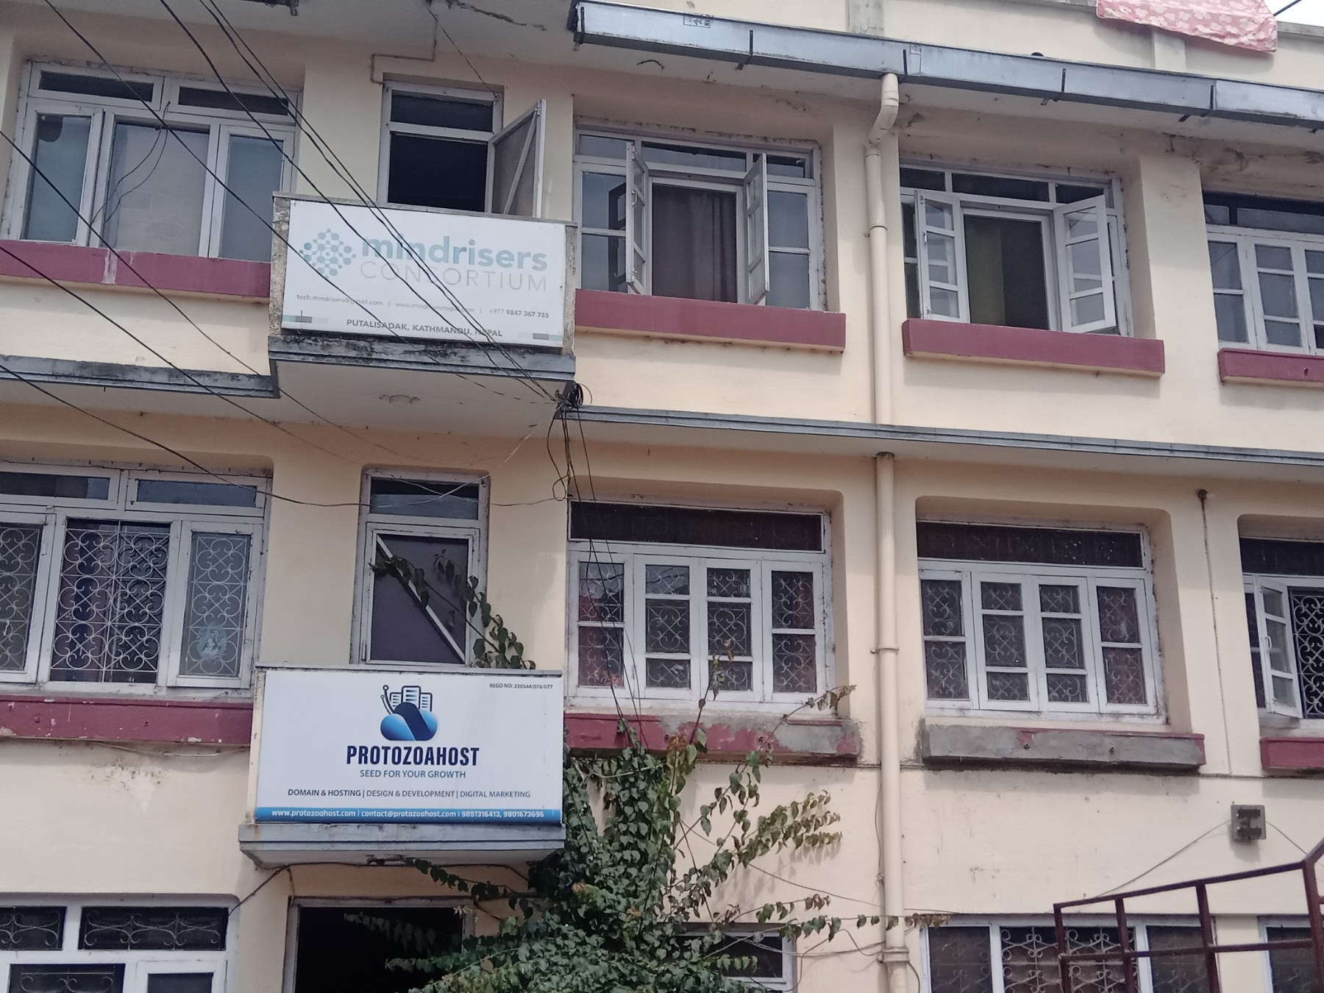

Fig 1: Office Building of Mind Riser's Consortium.
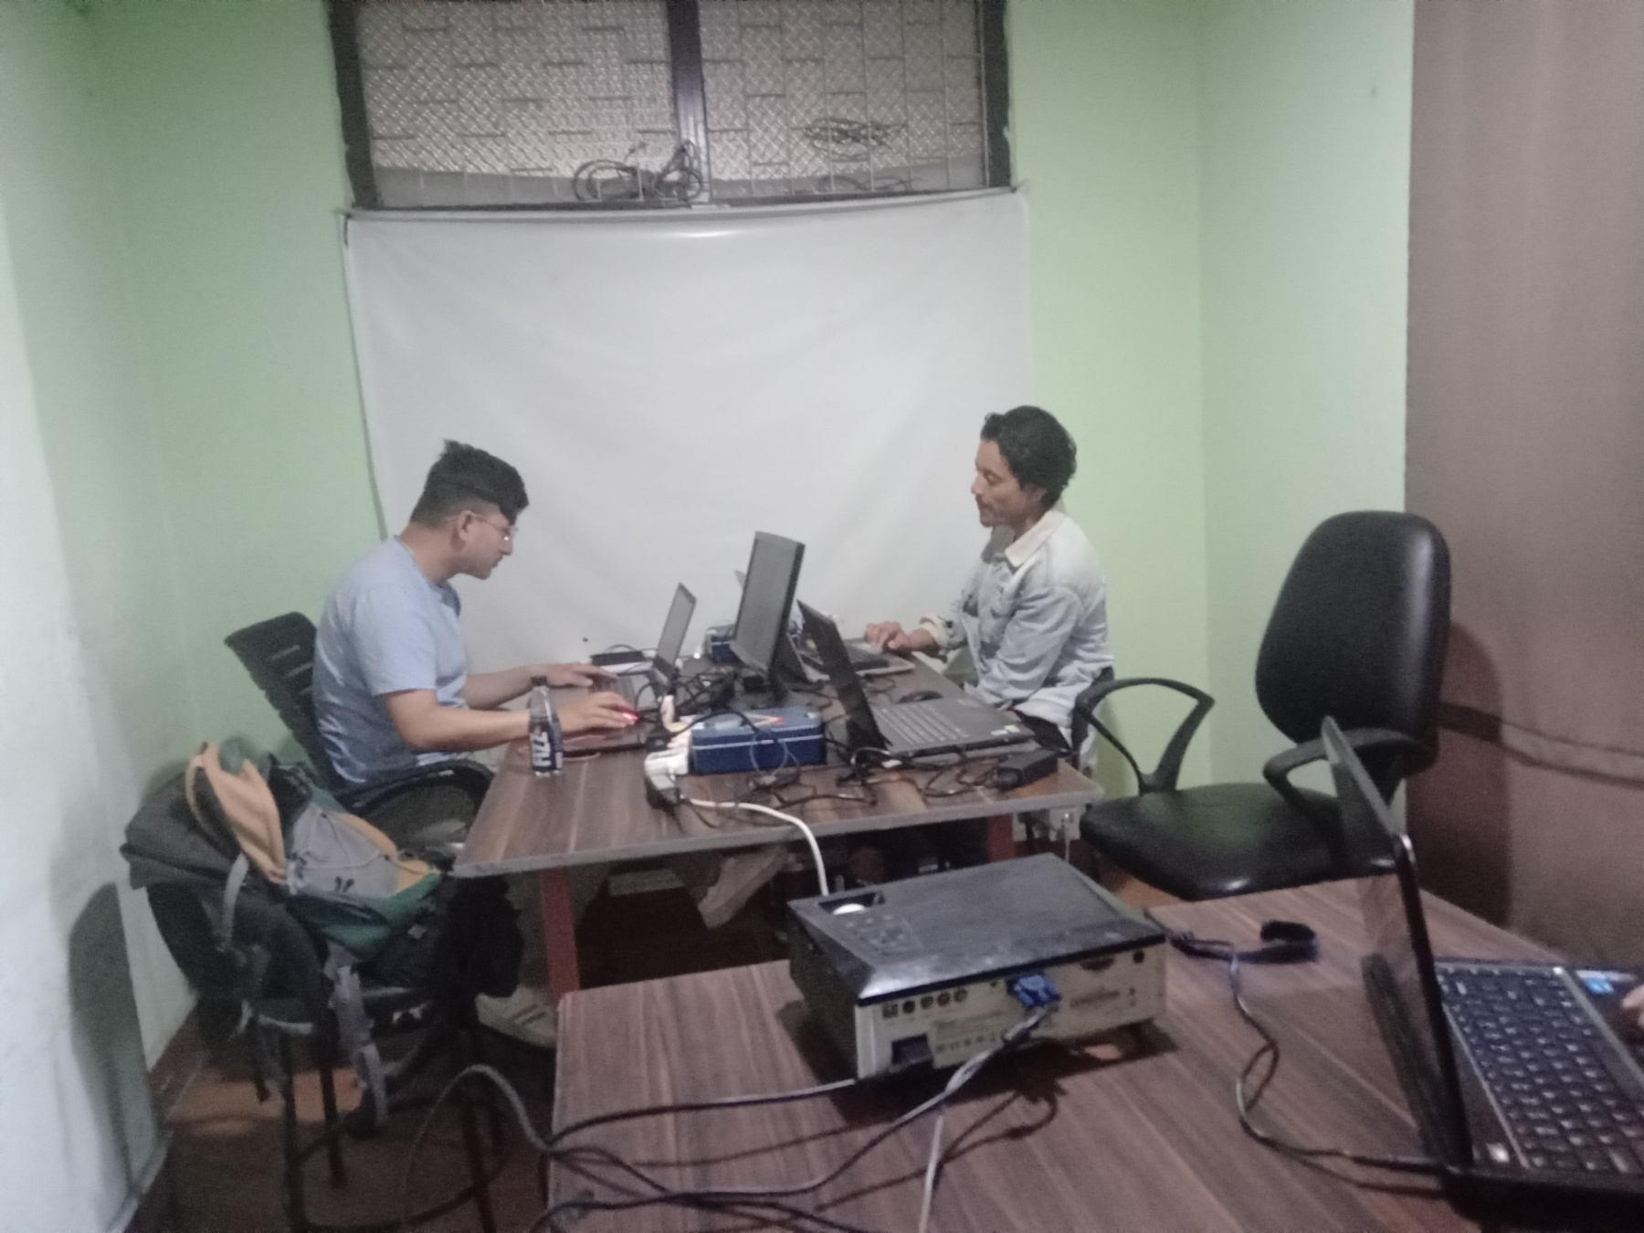

Fig 2: Interior Workspace of Mind Riser's Consortium.

